**­­­**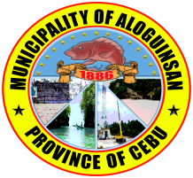

**Disaster Risk Reduction Management Plan for Health (DRRM-H)**

**CY 2023 – 2025**

**MUNICIPALITY OF**

**ALOGUINSAN**



**OFFICE OF THE MAYOR**

**MESSAGE**

**PLAN DESCRIPTION**

A. Description

The Aloguinsan Municipal Health Office’s DISASTER RISK REDUCTION MANAGEMENT PLAN FOR HEALTH(DRRM-H) is formulated to define the direction of this institution in preparing for effective and efficient response and recovery in any event of emergency or disaster within the municipality. The planning process includes hazard vulnerability analysis, thus coming up with a preparedness plan in response to any internal or external threat.

Its processes are directed primarily in reducing morbidity and mortality while preserving basic community service. It is directed to providing care to victims and providing coordination and control with other agencies especially with the Municipal Disaster Risk Reduction Management Office (MDRRMO). The plan is intended to enhance the ability of the public health workers to implement preparedness mitigation and recovery activities.

B. Scope of the Plan

The Disaster Risk Reduction Management Plan for Health(DRRM-H) is designed to assure appropriate, effective response to a variety of emergency situation that could affect the safety of constituents, staff and environment of the Municipality or adversely impact upon the LGU’s ability to provide health care services to the community. The plan is also designed to assure compliance with applicable law and mandates. The plan is applied to the Municipality of Aloguinsan.

***III. VISION, MISSION, GOALS and OBJECTIVES***

A. Vision -

To become a disaster-resilient municipality by ensuring a comprehensive and integrated health sector emergency management system.

B. Mission -

To administer a comprehensive emrgency management program in partnership with other department and offices in order to save lives, protect property and save the environment.

C. General Objective -

To enhance the office’s capacity for prompt and effective attendance to the largest possible number of people requiring medical and health care in a health emergency or disaster ultimately reducing mortality, morbidity, disability and promoting early recovery.

D. Specific Objectives

* To provide policy for effective response to both internal and external disaster situation that will affect the operation of the LGU.
* To identify the LGU capability to handle mass casualty in all scenarios.
* To identify responsibilities of individuals and departments in a disaster situation.
* To continuosly improve risk reduction framework of the Municipality of Aloguinsan.
* To promote health emergency preparedness through networking, inter-agency collaboration, technical assistance, training, public information, advocacy, research and development.
* To document best practices and lessons learned during emergencies and disasters.

**Chapter I. General Description**

**A. DEMOGRAPHIC and SOCIO-ECONOMIC PROFILE**

The Municipality of Aloguinsan is a 3rd class municipality with 15 barangays, 4 of which are coastal, the rest are inland, with a total land area of 6, 192 has. It is located in the Southwest portion of Cebu Island and with a distance of approximately 70 kms. From Cebu City. It is used to be a barangay of Pinamungajan. The main livelihood of the people are farming and fishing. Lately, ecotourism activities emerged as one of the economic drivers of the municipality. Only 30% of the land area are considered flat while the rest are sloping and rugged terrain. The dominant type of soil is limestone which largely influence the karst topography of the town. This is manifested by the presence number of caves and sinkholes. In some parts, the blue shale type of soil prevails causing difficulty of finding water source. Aloguinsan was among those established in the latter years under Spanish rule. During the early period of Spanish Colonization the areas covered by the town established in southwestern Cebu. The civil and religious functions were assumed by the town of Pinamungajan upon its official establishment in the middle of the 19th century. Thirty- six years later, Aloguinsan officially became a separate town, as ordered by King Alfonso XIII of Spain, through a Royal Decree issued in 1886.

***Common Livelihood***

**Geophysical Environment Map**

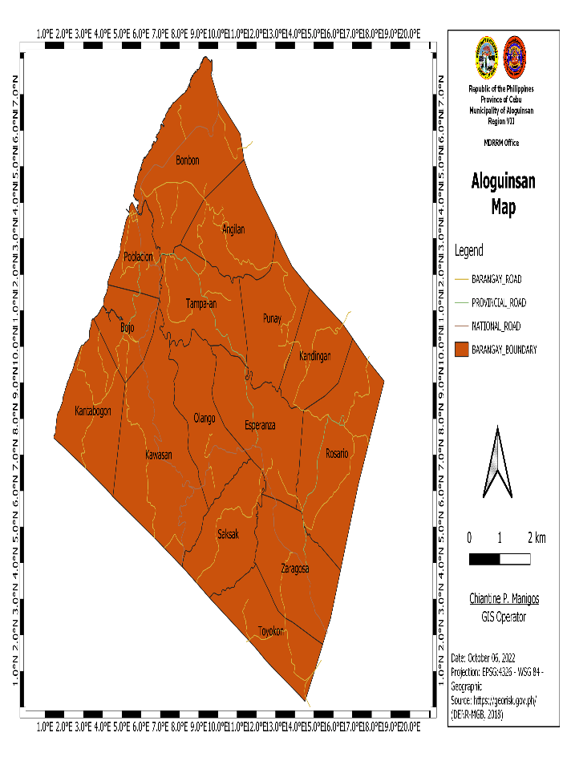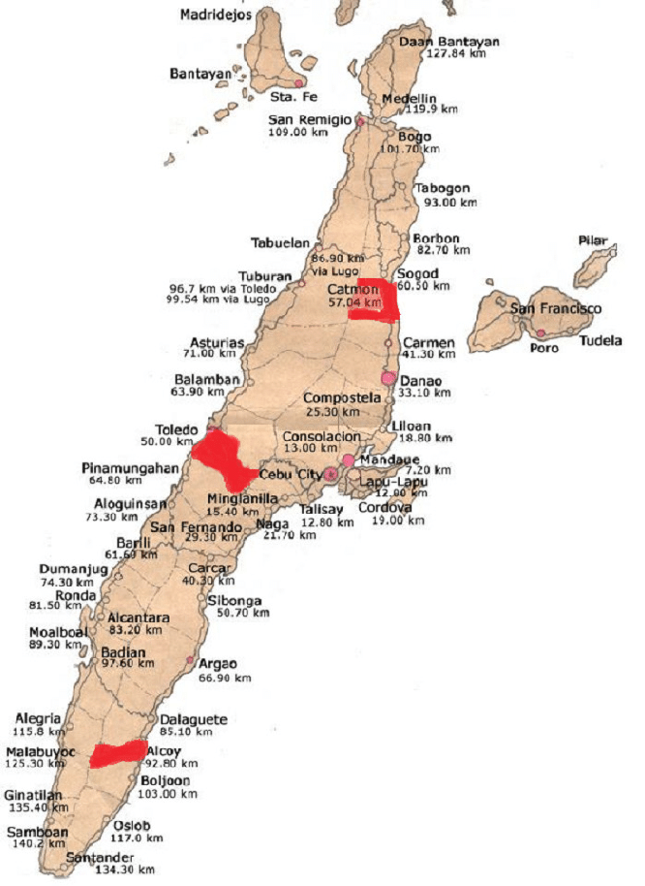

**ALOGUINSAN**

**B. DEMOGRAPHIC AND SOCIO-ECONOMIC PROFILE**

**Subdivision, Income Class and Economy**

Aloguinsan is a fourth class muncipality, belonging to the 3rd congressional district and to the BALODRON Interlocal Health Zone with the Municipalities of Barili, Dumanjug and Ronda.

Aloguinsan its main livelihood is agricultural. Fishing communities are also present in the area especially within the coastal barangays. It has piggery / poultry farms that contributed to an increase in the employment rate of the municipality. It houses the Top 100 Green Destinations in the world which is the “ BOJO RIVER”.

**POPULATION**

1. 1.1 Population Statistics 36, 303 with 7, 805 Households

This graph shows the population of Aloguinsan from 2019– 2022 which is increasing with a growth rate of 4.32%

|  |  |  |
| --- | --- | --- |
| **Barangay** | **Population** | **Household** |
| ANGILAN | 2, 979 | 640 |
| BOJO | 2, 114 | 455 |
| BONBON | 8,829 | 1, 898 |
| ESPERANZA | 2, 110 | 454 |
| KANDINGAN | 1, 060 | 228 |
| KANTABOGON | 1, 919 | 413 |
| KAWASAN | 2, 532 | 544 |
| OLANGO | 1, 302 | 280 |
| POBLACION | 3, 836 | 825 |
| PUNAY | 1, 746 | 375 |
| ROSARIO | 2, 113 | 454 |
| SAKSAK | 1, 308 | 281 |
| TAMPAAN | 2, 286 | 491 |
| TOYOKON | 784 | 169 |
| ZARAGOSA | 1, 385 | 298 |
| TOTAL | 36, 303 | 7, 805 |

The total population of Aloguinsan in 2022 is thirty six thousand three-hundred three (36, 303) with seven thousand eight hundred five (7, 805) households with Barangay Poblacion as the center for local businesses.

1. 1.2. Structure Distribution by Age & Sex (as of 2022)

|  |  |  |  |  |  |  |  |  |
| --- | --- | --- | --- | --- | --- | --- | --- | --- |
| **Age** | **Both Sexes** | **%** | **Age** | **Both Sexes** | **%** | **Age** | **Both Sexes** | **%** |
| **Under 1 year old** | **832** | **2.32%** | **12-59 months old** | **3,251** | **9.08%** | **10-19 years old** | **7,167** | **20.03%** |
| **0-6 months** | **486** | **1.36%** | **0-1 year old** | **1,638** | **4.58%** | **25 years old and above** | **17,093** | **47.79%** |
| **0-59 months** | **4,084** | **11.41%** | **2 years old and above** | **34,147** | **95.42%** | **60-65 years old** | **1,145** | **3.20%** |
| **6 months old** | **69** | **.19%** | **1-4 years old** | **3,251** | **9.08%** | **60 years old and above** | **2,624** | **7.33%** |
| **6-11 months old** | **416** | **1.16%** | **5-9 years old** | **3,932** | **10.99%** | **15-49 years old** | **9,244** | **4.85%** |
| **12-23 months old** | **805** | **22.50%** | **9-14 years old** | **4,421** | **12.35%** | **Highest: 25 y.o and above** | **Lowest: 6-11months old** | |

The age distribution has a broad base , with the population of young adult as the highest and 6-11 Months Old as Lowest.

**Transportation and Communication**

Road network to ALOGUINSAN is composed of national, provincial, municipal and barangay roads. National roads either cemented or asphalted with an average width of 6.1 meters. 50% are still gravel type roads specially barangay roads going to the mountain areas. Transportation servicing within ALOGUINSAN to the adjacent municipalities: Buses, Multi-cabs, Tricycle, Motorcycle, Bicycle.

ALOGUINSAN`s means of communication is by the use of telephones, VHF radios, fax machines, personal mobile phones and internet connection provided by Globe, Smart, Dito and Sun Cellular.

**C. HEALTH STATISTICS**

B1. Top 10 Leading Causes of Morbidity

**TEN LEADING CAUSES OF MORBIDITY**

On the top leading cause of morbidity , Upper Respiratory Tract Infection ranks first while Pneumonia and Dermatoses are equaled in ninth and tenth. This may show improvement on the health-seeking behaviour of our clients, thus, leading to early consultation, hence decreasing progression of disease. Pulmonary Tuberculosis may not be in the list, but, we have to exert more effort on prevention of Lung diseases. Hypertension, being the 2nd from the top may signify our efforts in masterlisting hypertensive patients especially during our profiling actiivities on our PHIC clients.

**B2. Top 10 Leading Causes of Mortality**

**TEN LEADING CAUSES OF MORTALITY**

The top ten leading causes of mortality is dominated by lifestyle-related diseases like Cardiovascular Illness , Cancer and Pneumonia.

**B3. Infant Mortality Rate**

***INFANT Mortality Rate***

The Infant Mortality Rate has been increasing since 2019 to 2021. Due to this result, we need to increase our efforts on our child health programs, so as to bring down steadily our Infant Mortality Rate.

|  |  |
| --- | --- |
|  | INFANT MORTALITY RATE |
| 2019 | 4.2% |
| 2020 | 10.50% |
| 2021 | 12.5% |

B4. Top 10 Leading causes of Neonatal Mortality

**B5.Top 10 Leading causes of under-5 Morbidity**

**B6.Top 10 Leading cause of under-5 Mortality**

***Under 5 – Mortality Rate***

Trending on the Under Five Mortality Rate is fluctuating, thus, we have to give more attention to our child health promoting programs.

B7. Maternal Mortality Rate

No maternal Mortality for the past 5 years

B8. Top 10 leading causes of Maternal Mortality

No maternal Mortality For the Past 5 years

B9. Malnutrition Rate

**Table B9.1**

**Nutritional Assessment of the Municipality of ALOGUINSAN**

|  |  |  |  |  |  |  |  |  |
| --- | --- | --- | --- | --- | --- | --- | --- | --- |
| **Barangay** | **Population**  **Children aged 6-59 mos.** | **Coverage of Measles Vaccination** |  | **Nutrition Assessment** | | | **SAM** | **MAM** |
| **Coverage of Vit. A Supplementation** | Green  ( Normal ) | Yellow  ( Wasted ) | Red  ( Severely wasted ) |
| ANGILAN | 362 | 46 |  | 175 | 2 | 0 | 0 | 0 |
| BOJO | 257 | 47 |  | 224 | 0 | 0 | 0 | 0 |
| BONBON | 1073 | 136 |  | 774 | 0 | 0 | 0 | 0 |
| ESPERANZA | 256 | 27 |  | 141 | 0 | 0 | 0 | 0 |
| KANDINGAN | 129 | 15 |  | 65 | 1 | 0 | 0 | 0 |
| KANTABOGON | 233 | 27 |  | 158 | 1 | 0 | 0 | 0 |
| KAWASAN | 308 | 36 |  | 156 | 1 | 0 | 0 | 0 |
| OLANGO | 158 | 19 |  | 97 | 1 | 0 | 0 | 0 |
| POBLACION | 466 | 59 |  | 249 | 0 | 0 | 0 | 0 |
| PUNAY | 212 | 18 |  | 112 | 0 | 0 | 0 | 0 |
| ROSARIO | 257 | 24 |  | 160 | 0 | 0 | 0 | 0 |
| SAKSAK | 159 | 19 |  | 67 | 0 | 0 | 0 | 0 |
| TAMPAAN | 278 | 30 |  | 137 | 1 | 0 | 0 | 0 |
| TOYOKON | 95 | 9 |  | 47 | 0 | 0 | 0 | 0 |
| ZARAGOSA | 168 | 20 |  | 61 | 0 | 0 | 0 | 0 |

**Table B9.2**

**Vaccination and Micronutrient Supplementation Coverage**

|  |  |  |  |
| --- | --- | --- | --- |
| **Barangay** | **Population of children aged 6 -59 months** | **Coverage of Measles Vaccination** | **Coverage of Vitamin A Supplementation** |
| ANGILAN |  |  |  |
| BOJO |  |  |  |
| BONBON |  |  |  |
| ESPERANZA |  |  |  |
| KANDINGAN |  |  |  |
| KANTABOGON |  |  |  |
| KAWASAN |  |  |  |
| OLANGO |  |  |  |
| POBLACION |  |  |  |
| PUNAY |  |  |  |
| ROSARIO |  |  |  |
| SAKSAK |  |  |  |
| TAMPAAN |  |  |  |
| TOYOKON |  |  |  |
| ESPERANZA |  |  |  |

**Table C1 Water, Sanitation and Hygiene**

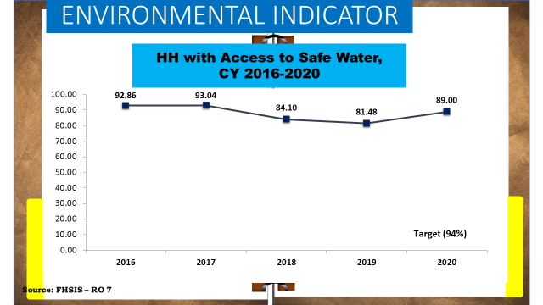

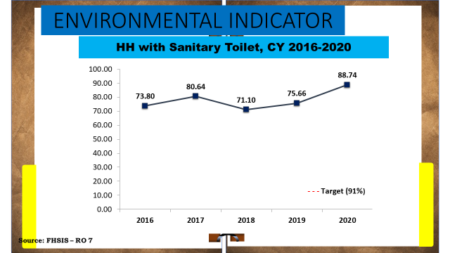

The number of households with Access to Safe Water is considerably high due to active and constant treatment of water sources. The percentage of safe water is around 89%. Sanitary Toilets is 88.74% of the total households. Giving free toilets and construction materials are made to achieve the Zero Open Defecation and also construction of commonal CR to highly populated and difficult areas. Furthermore, satisfactory Disposal of Solid Waste and With Complete Basic Sanitation Facilities of the Municipality of Aloguinsan.

**D. MANPOWER**

**D.1 Identified Health Personnel of Municipality of ALOGUINSAN**

|  |  |  |  |
| --- | --- | --- | --- |
|  | | | |
| Classification/Position | Name/Number | Organic Yes or No | Contact Details |
| Doctor | Dr. Gimbert T. Escasinas/1 | YES |  |
| PHN | Hilda S. Tolentino, RN  Judith B. Poncardas, RN  Blazer B. Delos Santos, RN | YES |  |
| RHM | Ma. Wilma Z. Ybanez  Beviana A. Nieves  Ana Mercedes A. Manguilimotan  Maridel L. Taping  Ruth E. Agustin  Catherine E. Encarnacion  Merry Jane G. Trencio  Jenenia E. Inocando | YES |  |
|  |
| Sanitation Inspector | Alfe L. Dacuma | YES |  |
| Dentist | Marchie C. Mabala | NO/DOH Augmented |  |
| Medical Technologist | Jennifer L. Sayson | YES |  |
| BHWs | 133 | NO |  |
| BNS | 15 | NO |  |

Their are limited health manpower working in the entire Sibonga, thus clustering of Barangays were used to augment the lack of staff working.

1. **SOCIO-ECONOMIC PROFILE**

I. EDUCATION :

Provision of education is from Day Care/Nursery/Kindergartens to College. Below is the list of schools or facilities within the municipality.

1. Day Care Centers:

Private - 0

Public - 15

1. Kindergarten

Private - 0

Public - 15

1. Elementary Schools:

Private - 0

Public - 15

1. Secondary Schools:

Private - 0

Public - 3

1. Tertiary Schools:

Private - 0

Public 0

II. Poverty Incidence and Number of NHTS:

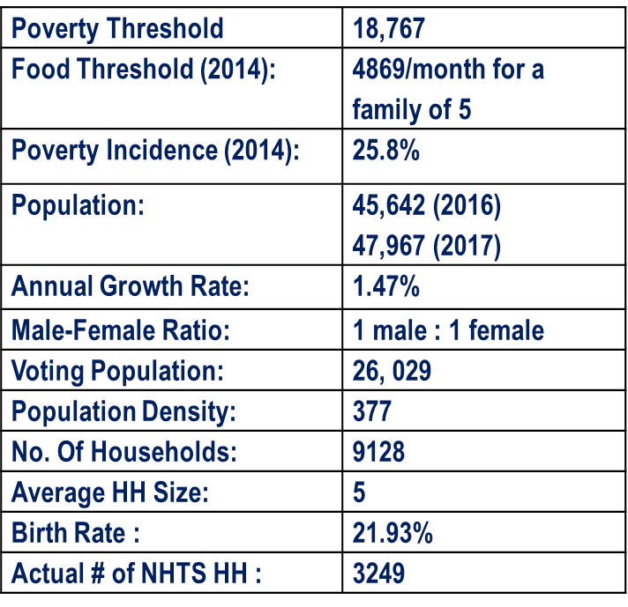

III Health Facilities

Table A.1

List of Health Facilities in the Municipality of Aloguinsan

|  |  |  |  |  |  |
| --- | --- | --- | --- | --- | --- |
| Classification | Type | Name of HF | Area covered | Services Provided | Others ( Bed Capacity, Inventory of Vehicles ) |
| PUBLIC | Public   * RHU | Saloguinsan Municipal Health Office | 15 Barangay of the Municipality | Promotive and Preventive care | 1 ambulance |
| PUBLIC | Public   * Lying-in/Birthing Center | Aloguinsan Birthing Center | 15 Barangay of the Municipality | Ante Natal, Post Natal, Facility Based Delivery | 3 bed Capacity WARD  4 bed Capapcity Labor Room |
| PUBLIC | Public   * Barangay Health Station | Poblacion BHS | Barangay: Bojo, Tampaan, Kantabogon, Poblacion | Promotive and Preventive care, Ante Natal, Post natal, EPI | Catchment Area |
| PUBLIC | Public   * Barangay Health Station | Bonbon BHS | Barangay: Bonbon, Angilan | Promotive and Preventive care, Ante Natal, Post natal, EPI | Catchment Area |
| PUBLIC | Public   * Barangay Health Station | Olango BHS | Barangay: Olango, Kawasan, Saksak | Promotive and Preventive care, Ante Natal, Post natal, EPI | Catchment Area |
| PUBLIC | Public   * Barangay Health Station | Rosario BHS | Barangay: Rosario, Punay, Kandingan | Promotive and Preventive care, Ante Natal, Post natal, EPI | Catchment Area |
| PUBLIC | Public   * Barangay Health Station | Zaragosa BHS | Barangay: Zaragosa, Esperanza, Toyokon | Promotive and Preventive care, Ante Natal, Post natal, EPI | Catchment Area |

Table A.2

Referring Agencies

|  |  |  |  |  |  |
| --- | --- | --- | --- | --- | --- |
| Classification | Type | Name of HF | Bed Capacity | Distance | Contact /Point Person with Contact Details |
| Public | Public   * Hospital | Dr. Jose Ma. Borromeo Memorial District Hospital | 20 bed Capacity | 15km |  |
| PUBLIC | Public   * Hospital | Cebu Provincial Hospital | 50 bed Capacity | 32km | Dr. Daisy Lou Abarquez |

Table A.3

**List of Health Facilities currently enrolled to Rehab or HFEP**

|  |  |  |  |  |  |  |  |
| --- | --- | --- | --- | --- | --- | --- | --- |
| Name of HF | Description | Amount received | Supporting Agency/s | Status | Estimated completion date | Percentage of Completion | Remarks |
| None | None | none | none | none | None | None | none |

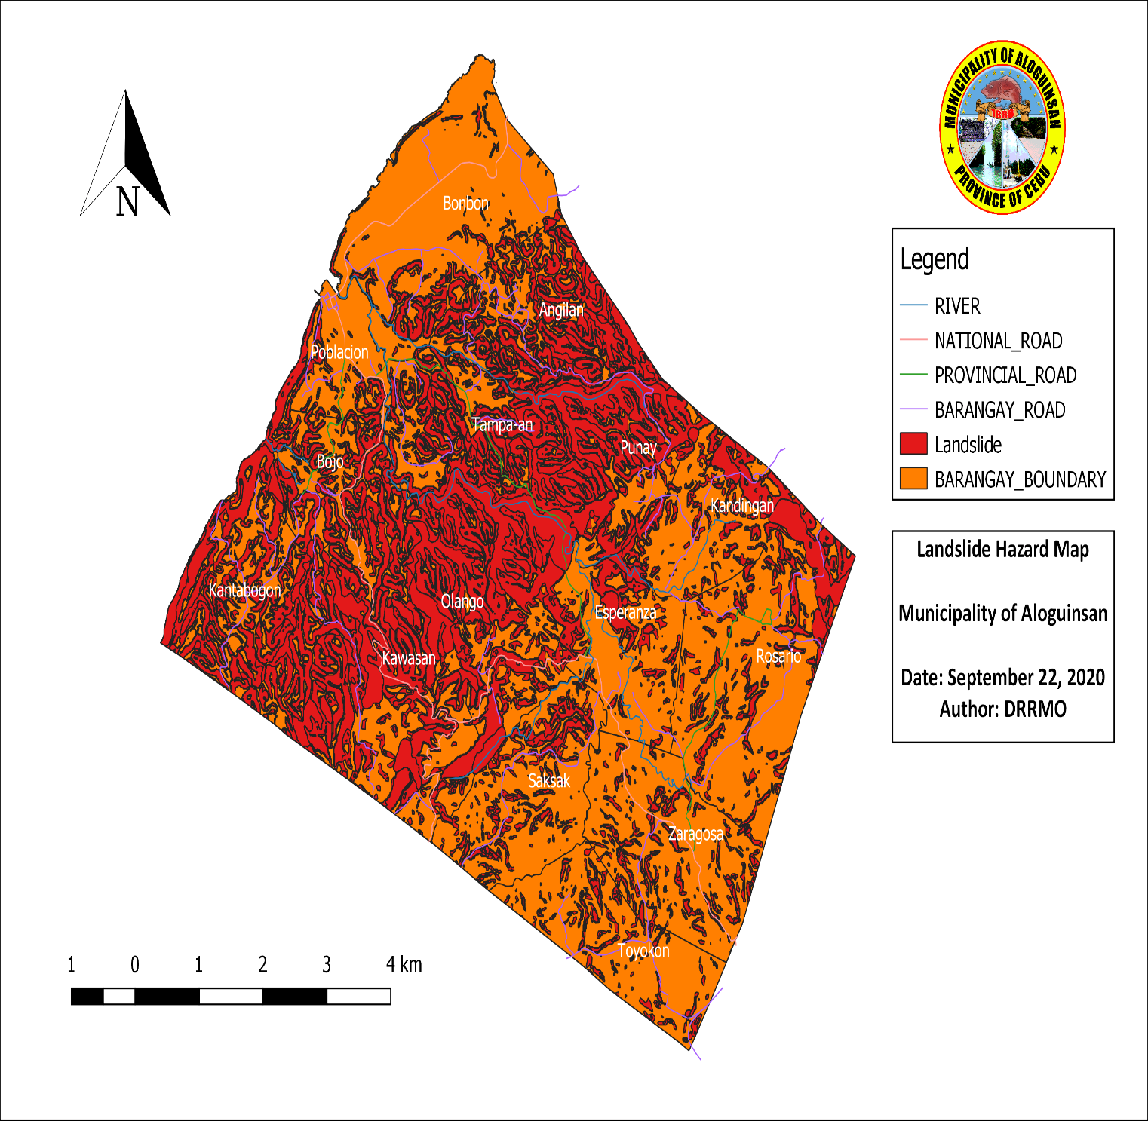**GEOHAZARD MAP**

LANDSLIDE

FLOOD

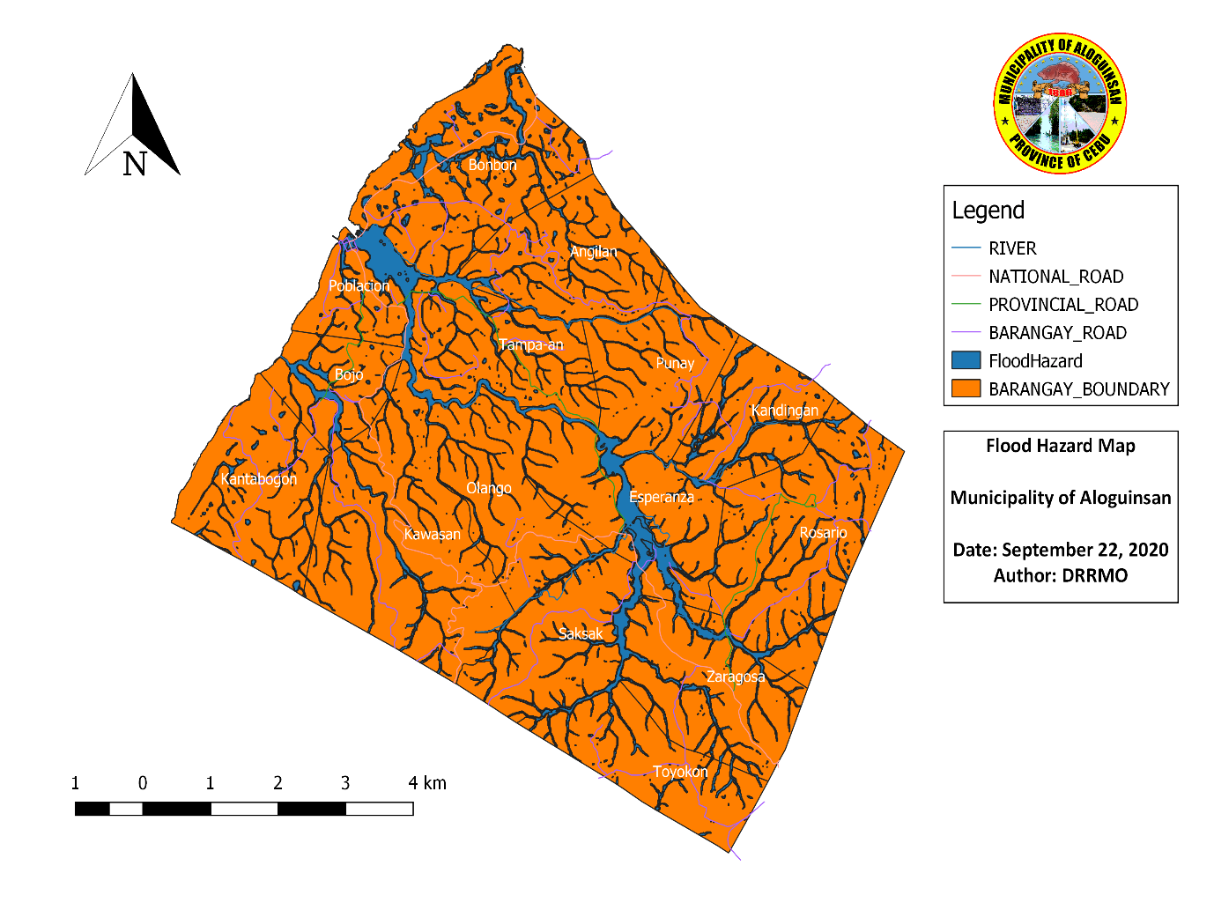

|  |  |
| --- | --- |
| Areas that are: | **Name of Barangay** |
| Coastal Barangay’s | BONBON |
| POBLACION |
| BOJO |
| KANTABOGON |
| Flood Prone Area (High) | Poblacion |
| Bonbon |
| Bojo |
| Esperanza |
| Saksak |
|  |
| Landslide Prone Area (High) | Kawasan |
| Kantabogon |
| Kandingan |
| Punay |
| Angilan |
| Poblacion |
| Bojo |
| Olango |
| Tampaan |
| Esperanza |
| Areas Near/Under Fault Lines |  |
|  |
|  |
|  |
|  |
|  |

1. HAZARD IDENTIFICATION AND PRIORITIZATION

|  |  |  |  |  |  |  |  |
| --- | --- | --- | --- | --- | --- | --- | --- |
| **Hazard** | **Severity (A)** | **Frequency (B)** | **Extent** | **Duration (D)** | **Manageability** *(E)x 2* | **Total** | **Ranking** |
| **( C)** | *(A+B+C+D)-E* |
| 1. Natural |  |  |  |  |  |  |  |
| Typhoon | (STS) 89-117 km/h – (TY) 118-184 km/h | 6 (Tropical Cyclone) every year | 10 km (eye) | 2 days | 1 |  |  |
| Earthquake |  |  |  |  |  |  |  |
| Flood/ Flashflood | Moderate (5) | Once every 2 years | Flood Depth 1.0 – 2.0 | 3 days (3.34) | 2 |  |  |
| El Niño |  |  |  |  |  |  |  |
| Land slides | Moderate (5) | Once every 3 years | Elevation variation (meter) 7~3 | 2 days | 2 |  |  |
| 2. Biological |  |  |  |  |  |  |  |
| Emerging/Re-emerging Diseases DENGUE |  |  |  |  |  |  |  |
| Diarrhea |  |  |  |  |  |  |  |
| COVID 19 disease |  |  |  |  |  |  |  |
| 3. Technological |  |  |  |  |  |  |  |
| Fire |  |  |  |  |  |  |  |
| vehicular accident | 800+ motor vehicular accident (MVA) from 2018-2024 | 1-2 (MVA) every month | 100m radius | 1-30 minutes | 2 |  |  |
| 4. Societal |  |  |  |  |  |  |  |
| Traffic Jam during Fiesta |  |  |  |  |  |  |  |
| Fraternity/Gang Conflicts |  |  |  |  |  |  |  |

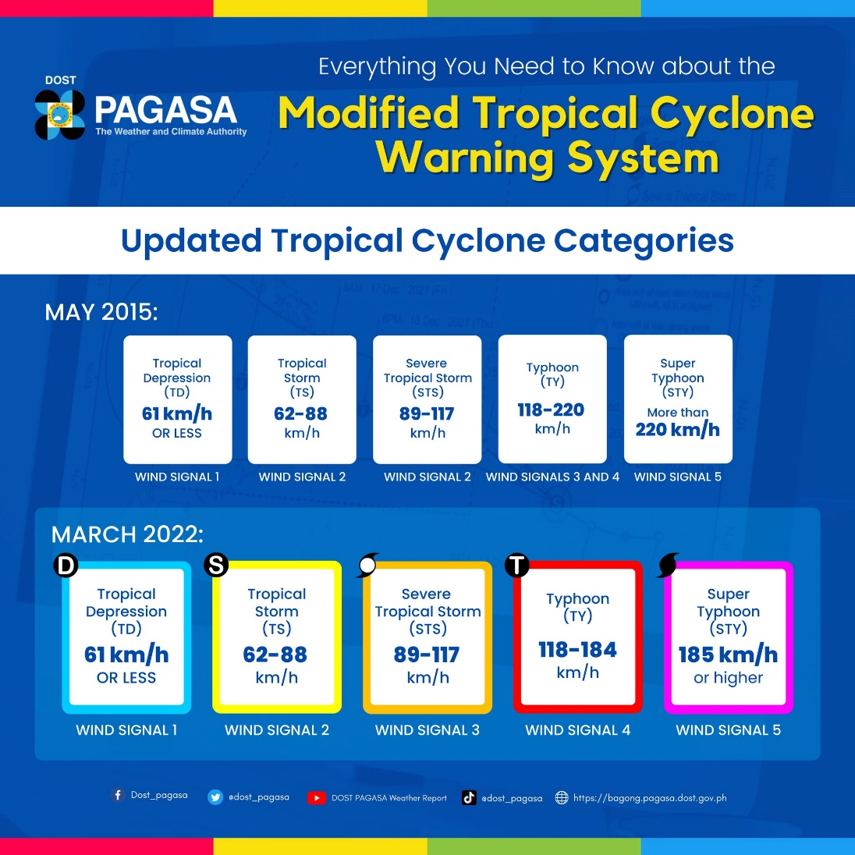

**Scoring Guide:**

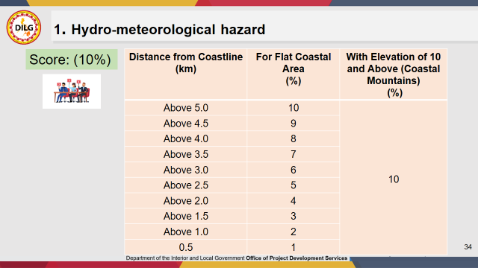

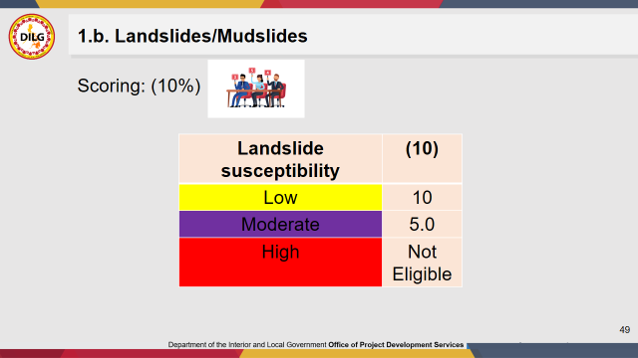

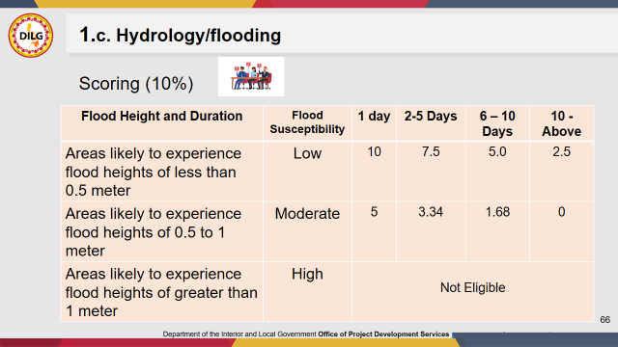

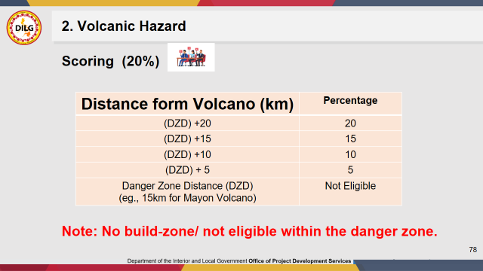

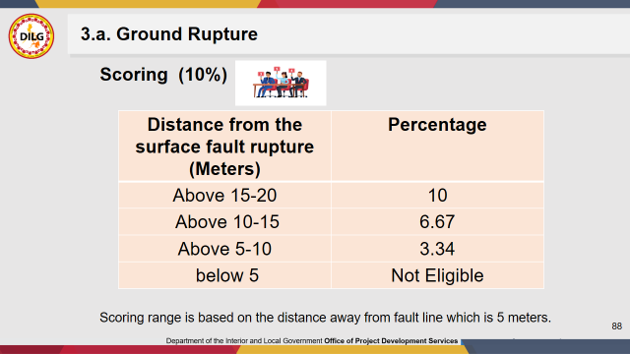

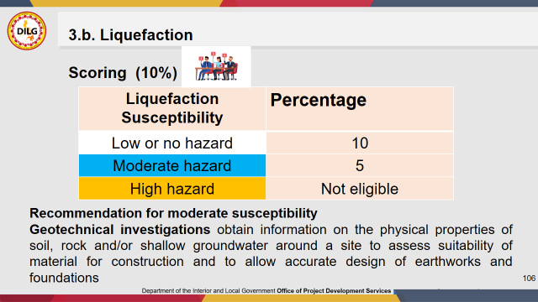

1. **HAZARD MAPPING**

LEGEND:

1. Vehicular Accident
2. COVID19
3. FLOOD/FLASHFLOOD
4. TYPHOON
5. EL NIÑO
6. LANDSLIDE
7. DENGUE
8. EARTHQUAKE
9. FRATERNITY/GANG WAR
10. TRAFFIC JAM DURING FIESTA
11. FRATERNITY/GANG CONFLICT

2,3,4,6,7,9

1,2,4,5,6,7,8,9,10

2,3,4,6,7,9

2,3,4,6,7,9

1,2,4,5,6,7,8,9,10

1,2,4,5,7,8,9

2,3,4,5,7,8

1,2,3,4,5,6,7,8,9,10

1,2,3,4,5,6,7,8,9,10

1,2,4,5,6,7,8

1,2,4,5,6,7,8

1,2,4,5,6,7,8,

1,2,3,4,5,6,8,7,9

1,2,4,5,6,7,8

2,3,4,6,7,9

2,3,4,6,7,9

2,3,4,6,7,9



1. **VULNERABILITY ASSESSMENT MATRIX**

|  |  |  |  |  |  |
| --- | --- | --- | --- | --- | --- |
|  | | | | | |
| **Hazard** | **Vulnerable Areas** | **Vulnerabilities** | | | |
| **People** | **Properties** | **Services** | **Environment** |
| **vehicular accident** | Intersections,  Merging lanes,  Sharp curves,  Narrow roads,  Work zones,  School zones,  High-risk driver | Physical injuries,  Psychological trauma,  Loss of life;  Pedestrians,  Cyclists,  Motorcyclists | Vehicular damage,  Infrastructure damage:  Streeetlights,  Guardrails,  Building damage | Traffic disruption:  Delaying emergency vehicle,  public transportation,  Emergency response strain:  Police,  Ambulance crews | Pollution:  Leaks of oil,  Coolant,  Other fluids from damaged vehicles,  Fire,  Habitat disruption |
| **Flood** | Low-lying area:  Places near rivers, coasts,  Floodplains,  Areas with poor drainage | Physical injuries:  Drowning,  Injuries from debris,  Trauma: flood can be very stressful and lead to anxiety, depression | Homes and buildings,  Infrastructure: roads, bridges, power grids,  Businesses | Emergency services,  Utilities: damage power lines,  Transportation | Water pollution,  Habitat destruction,  Land Degradation |
| **Typhoon** | Coastal areas,  Low-lying areas,  Poorly built structures | Physical injuries,  Displacement and Evacuation,  Loss of life,  Health risks,  Psychological Trauma | Homes and buildings,  Infrastructure: roads, bridges, power grids,  Businesses | Emergency services,  Utilities: damage power lines,  Transportation | Water pollution,  Habitat destruction,  Land Degradation |
| **El Niño** |  |  |  |  |  |
| **Dengue** |  |  |  |  |  |

1. **RISK ASSESSMENT**

|  |  |  |  |  |
| --- | --- | --- | --- | --- |
| **Government agencies/Non-government organizations/Civil Society Organizations** | **Services/products that may be utilized in times of disasters/emergencies** | **Contact person/s** | **Contact details** | **Focal person** |
|  |
| **Municipal Disaster Risk Reduction Management Office** | **Risk assesment, Conduct of capacity building activities, Information and Dissemination Campaign, Response Operation, Assist Pre-emptive evacuation, conduct Rapid Damage assessment and needs analysis, and post disaster needs assessment** | **Shane M. Navarro** |  | **Chiantine Manigos** |
| **Municipal Health Office** | **Preventive, promotive and curative services** | **Dr. Gimbert T. Escasinas** |  | **Blazer B. Delos Santos** |
| **Municipal Social Work and Development Office** | **Camp Management, Psychosocial Counseling, Relief Goods supply** | **Ma. Corazon Ricaforte** |  | **Geraldine Macabenta** |

1. **External DRRM-H institutionalization Matrix**

|  |  |  |  |  |  |  |  |  |  |  |  |
| --- | --- | --- | --- | --- | --- | --- | --- | --- | --- | --- | --- |
| |  | | --- | | **Region / Province / City/ Muni-cipality / Barangay** | | **Head of Institution** | **Head of the Health Office of the Institution** | **Available**  **DRRM Plan** | **DRRM-H Plan** | |  | | --- | | **Health Emergency Response Team** | | |  | | --- | | **Health Emergency Commodi-ties** | | |  | | --- | | **Emergency Operations Center** | |
| **Aloguinsan** | **Hon. Cesare Ignatius G. Moreno** | **Dr. Gimbert T. Escasinas** | **yes** | **ongoing** | **Yes** | **yes** | **Yes** |
|  |  |  |  |  |  |  |  |
|  |  |  |  |  |  |  |  |
|  |  |  |  |  |  |  |  |

|  |  |  |  |  |
| --- | --- | --- | --- | --- |
| **Categories** | **Bases** | | | |
|  | □ | □ | □ | □ |
| |  | | --- | | DRRM-H Plan | | Updated | Approved by the authority of the organization | Disseminated | Tested annually |
|  | □ | □ | □ |  |
| Health Emergency Response Team | Organized to provide initial basic services | Trained on BLS | Trained on SFA |  |
|  | □ | □ |  |  |
| Health Emergency Commodities | Available Health Emergency Medicines* | Accessible within 24 hrs |  |  |
|  | □ | □ | □ |  |
| Functional Emergency Operations Center | Command and Control | Communication | Coordination |  |

|  |  |  |  |
| --- | --- | --- | --- |
| **Health Risk Assessment Matrix** | | |  |
|  |  |  |  |
| **Hazard** | **Vulnerabilties** | **Capacity** | **Risk** |
| **vehicular accident** | underaged drivers, unlicensed and irresponsible drivers. Lack of Road Signages, and use of Non Conditioned Vehicle. non-functional and untrained BDRRMC, Slippery Roads, Presence of Blind Curves and Mountainous Terrain | **Organized and trained Local responder** | **Death, Injuries/disabilities, Damage to properties** |
| **flood** | Lack of knowledge on pre-emptive evacuation. houses and other infrastructures near the riverbanks with improper drainage, system, vehicles, appliances, livestocks, crops. untrained personnel on WASAR. Lack of Knowledge in proper waste disposal. | **Organized and trained Local responder** | **Death, Injuries/disabilities, Damage to properties** |
| **typhoon** | Lack of knowledge on pre-emptive evacuation. houses and other infrastructures near the riverbanks with improper drainage, system, vehicles, appliances, livestocks, crops. untrained personnel on WASAR. Lack of Knowledge in proper waste disposal. houses made of light materials and other infrastructures near the riverbanks with improper drainage, system, vehicles, appliances, livestocks, crops. lack of perosonnel, Logistics and supplies. Health Facility and MDRRM Office are near the Coastal Area, Coastal Barangay. | **Organized and trained Local responder** | **Death, Injuries/disabilities, Damage to properties** |
| **El Niño** | Especially farmers are incapable to handle El-Nino Effects, Choice of non-resilient crops, Less provision of better alternatives than traditional farming, Scarcity of Water supply, Rampant Cutting of Trees |  |  |
| **Dengue** | Lack of Knowledge on Environment and Sanitation, Improper storage of water, Lack of RSI, PHN, Medtech and inactive Barangay Dengue Task Force, Presence of several mosquito Breeding Sites and unsanitary environment |  |  |

|  |  |  |  |  |  |  |  |  |
| --- | --- | --- | --- | --- | --- | --- | --- | --- |
| **Hazard Reduction/Prevention Plan of Aloguinsan** | | | | | | | | |
| **Hazards** | **Vulnerability** | **Preventive Strategies/ Activities** | **Time Frame** | **Resource Requirement** | | | **Person Responsible** | **Indicators** |
| **Required** | **Available** | **Source** |
| **Vehicular Accident** | **underaged drivers, unlicensed and irresponsible drivers.** | **monitoring of vehicle registration and drivers license** |  |  |  |  |  |  |
| ► Coordinate Local PNP to conduct checkpoint activity | Jan to Dec 2018 | signages | Materials/ supplies | LGU, DRRM fund, DPWH | LCE, MHO, MBO, MDRRMO, MEO, PNP | road signages/traffic signs produced decrease no. of incidence in vehicular accident |
| ►Require all vehicular accident victims to have a police blotter |
| **Lack of Road Signages.** | enhance early warning system like road signages/trafiic signs |
| ►coordinate with the DPWH |
| ►indentify areas needing signages |
| **non-functional and untrained BDRRMC** | Reorganization and/or activation of BDRRMC in all 15 Barangays |
| ►Request the LCE to issue an executive order for the organization of BDRRMC |  |  |  |  |  |  |
| ►Lobby to ABC to craft a barangay resolution for the reorganization of their respective BDRRMC |  |  |  |  |  |  |
| **Slippery Roads, Presence of Blind Curves and Mountainous Terrain** | to develop mitigation measures |  |  |  |  |  |  |
| ►coordinate with the DPWH |  |  |  |  |  |  |
| ►install additional signages/ road warning signs |  |  |  |  |  |  |
| **Flood** |  | Policy Development | year round | funding, venue, lecturers | manpower, transpo, TEV, logistics | LGU, DRRM fund, DSWD funds | LCE, MHO, MBO, MDRRMO, DSWD | no. of policy developed |
| awareness to flood prone areas in terms of mitigation | no. of clients given services |
| •enhance alert system |
| •awareness on the importance of water and sanitation |
| Request for the updating of the CLUP and the Municipal Zoning Ordinance | 1st Quarter of 2018 | Data of CLUP | manpower | LGU, DRRM fund | LCE, MHO, MDRRMO, MEO | Updated CLUP |
| Coordinate with MPDC for possible relocation |  |  | manpower |  |  | Identified relocation |
| **Typhoon** |  | •Awareness on what to what to do before, during and after typhoon | year round | funding, venue, lecturers | manpower, transpo, TEV, logistics | LGU, DRRM fund, DSWD funds, BDRRM Fund | LCE, MHO, MBO, MDRRMO, DSWD, BLGU | no. of clients given services |
| •Enhancing the LGU's capability on pre emergency care |
| •Enhance alert System, Communication System and Protocols |
| •Training on Skeletal force personnel |

|  |  |  |  |  |  |  |  |  |
| --- | --- | --- | --- | --- | --- | --- | --- | --- |
| **Table V.D. 1 Risk Preparedness Plan of Aloguinsan** | | | | | | | | |
| **Risks** | **Capacity Needed** | **Preparedness Strategies/ Activities** | **Time Frame** | **Resource Requirement** | | | **Person Responsible** | **Indicators** |
|
| **Required** | **Available** | **Source** |
| 1. Death | Policy | 1. Policy Development | **ASAP** | Policy adopting on AO 168 | Manpower (SB) | DOH website HEMS | MHO/HEMS Coordinator/HR/LHB | Develop Policy adapted to A.O 168 |
| 2. Injury |  | a. Adopt the A.O 168-Nat Policy on Disaster/Emergency Management |
| 3. Disease ( dengue) | PLANS | **2. System Dev't** | 2018-2020 | Technical working group, Funds for Meetings and write-shops | HEMS coordinator | Technical Working Group Funds for meetings and write-shops | LCE/MHO/LHB | EMERGENCY PREPAREDNESS RESPONSE AND RECOVERY PLAN DEVELOPED AND IMPLEMENTED |
| 4. Damage to infrastructure | a. Logistics Management |
| 5. Breakdown of Essential Services | b. Public Information |
| 6. Displacement | c. Information Management |
| 7. Breakdown in security | d. Communication System |
|  | e. Resource Mobilization |
|  |  | **3. Plan Development** | 2018-2017 | Expanded LHB, DRRM Council | HEMS coordinator | LHB members, DRRM staff | HEMS COORDINATOR, LHB planning committee | EMERGENCY PREPAREDNESS RESPONSE AND RECOVERY PLAN DEVELOPED AND IMPLEMENTED |
|  | 3.1 Risk Reduction Plan |
|  | a. Hazard Prevention Plan |
|  | b. Vulnerability Readiness Plan |
|  | c. Emergency Preparedness Plan |
|  | d. Emergency Response Plan |
|  |  |  |  |  |  |  |  |  |

|  |  |  |  |  |  |  |
| --- | --- | --- | --- | --- | --- | --- |
| **Public Health - Preparedness Plan Matrix 2: Minimum Requirements of DRRM-H Institutionalization** | | | | | | |
| **DRRM-H Institutionalization Priorities** | **Strategies and Activities** | **Time frame** | **Resource** | | **Person in charge** | **Indicator** |
| **Required** | **Source** |
| Internal | Completion and approval of DRRM-H Plan | | | | | |
| Inform LCE and SB on Health on the crafting DRRM-H Plan Through the ELHB or MDRRMC Meeting | Jul-18 | None |  | MHO, MDRRMO | ELHB/MDRRMC minute and attendance |
| Present the Rough Draft of DRRM-H Plan to the MDRRMC for comments, suggestion and optimately for its approval | Jul-18 |  |  | MHO, MDRRMO | approved DRRM-H PLAN |
| None |
| Strategy 2 | | | | | |
| External | Coordinate with DOH on Trainings of the Health Emergency Response Team |  |  |  |  |  |
| BLS trainings | Oct-18 | Trainors from DOH | DOH | HEMS SECTION of DOH RO7 | BLS training done with attendance sheet of the participants |
|  |  | Training Proposal | MHO/MDRRMO | MHO, MDRRMO |  |
|  |  | Training Supplies | LGU | MHO, MDRRMO |  |
|  |  | Meals and venue | LGU | MHO, MDRRMO |  |
|  |  |  |  |  |  |
| Emergency response training |  | Resrouce Requirement 1.2 | Source 1.2 | In charge 1.2 | Indicator 2.1 |
| ACLS Training |  |  |  |  |  |

***Table 10. Public Health - Response Plan***

|  |  |  |  |  |
| --- | --- | --- | --- | --- |
| **Activity** | **Steps to be undertaken** | | | **Responsible Person/**  **Institution/ Agency** |
| **Pre- Impact (0 day)** | **Impact**  **(0-48 hrs)** | **Post- Impact (>48 hrs)** |
| **Management of the Event/ Incident** | | | | |
| Activate Operation Center (OpCen) on a 24/7 basis and Incident Comand System (ICS) | Assess the situation, Activation of Incident Management, Activation of Emergency Operation Center, Team, Public Health Participation in emergency operation center, ensure that site health and safety plan is established, Established Communication with key health personnel and other health providers, assigned or deploy resources and assets strategically to achieve established initial health response and Address request for assistance and information. | Verify that Health surveillance system are operational, Ensures that laboratories likely to be used during the response are operational and verify their analytical capacity, Ensure that the needs of special populations are being address, Communicate whether or not health related volunteers and donation needed, collect and analyze data that are becoming available through health surveillance and laboratory systems, prepare and update information for shift change and executive briefing, prepare for onsite assistance, assess health resource needs and aquire as necessary | address mental and behavioral health support needs, prepare fotr transition to extended operations or response disengagement, Rapid damage assesment and needs analysis team deployed. Management of the dead and the missing. Camp management. Linkages of different sectors/assets for possible need of additional assistance. | Incident Management Team |
| Raise appropriate code alert |  |  |  |  |
| Inform higher level of OpCen, if not DOH-OpCen of the Incident through fastest means of communication |  |  |  |  |
| Coordinate with respective DRRM Office, with partner agencies, and attend/conduct meetings as necessary (DRRMC, health sector, cluster partners) |  |  |  |  |
| **Management of Information System** | | | | |
| Gather information regarding the event  -Coordinate with health representative and get initial report  -Deploy Rapid Health Assessment (RHA) Teams when no communication/ report from the health representative in 6 hours post impact  -Submit initial assessment report using official RHA form. |  |  |  |  |
| Continuous monitoring and dissemination of information updates |  |  |  |  |
| Submission of daily situation report or HEARS report to the upline |  |  |  |  |
| Surveillance in Post extreme Emergencies and Disaster (SPEED) activation |  |  |  |  |
| **Management of Service Providers** | | | | |
| Check status of health personnel in affected areas |  |  |  |  |
| Mobilize own human resources or request assistance for:  Additional RHA team  Emergency medical and public health team  WASH team  MHPSS team  Nutrition team  RESU team  Other teams that may be needed (maintenance, admin support, etc.) | Ensure availability and adequacy of medical supplies and equipment, Skeletal force convene for briefing logistics preparation, and advisories, |  |  |  |

|  |  |  |  |  |
| --- | --- | --- | --- | --- |
| **Activity** | **Steps to be undertaken** | | | **Responsible Person/ Institution/ Agency** |
| **Pre- Impact**  **(0 day)** | **Impact**  **(0-48 hrs)** | **Post- Impact**  **(>48 hrs)** |
| **Management of Non-human Resources** | | | | |
| Update/check status/inventory of logistics |  |  |  |  |
| Preposition logistics as per result of inventory |  |  |  |  |
| Mobilize own non-human resources or request assistance for:  Medicines and medical supplies  WASH supplies and equipment  Nutrition commodities  -MHPSS supplies and commodities  Funds  Others |  |  |  |  |
| **Management of the Victims** | | | | |
| Provide pre-hospital and hospital care |  |  |  |  |
| Provide quad cluster health services  (e.g. general consultation and treatment, vaccinations, reproductive health services,chemoprophylaxis, health education, promotion and advocacy including hygiene, nutrition and psychosocial support) |  |  |  |  |

**Public Health - Recovery and Rehabilitation Plan: Standard Operating Procedures**

|  |  |  |
| --- | --- | --- |
| **Activity** | **Steps to be undertaken** | **Responsible Person/**  **Institution/ Agency** |
| Post damage assessment and needs assessment | **Organized PDNA team**  **Deployment of PDNA to the afftected areas**  **Consolidate gathered data**  **Submit report to higher DRRMC** | **MDRRMO/MHO/ME/MAO** |
| Post incident evaluation and documentation of lessons learned | **Convene the MDRRMC** | **MDRRMO** |
| Review and updating of DRRM-H plan | **core team to review the plan** | **MHO/MDRRMO** |
| Psychosocial interventions | **Activate the team who will conduct psychosocial intervention** |  |
| Repair of damaged health facilities and lifelines | **Coordinate with ME and other concern agency for the repair** |  |
| Repplenishment of utilized resources | **Inventory of supplies and logistics**  **Request of procurements** |  |
| Compensation and recognition of responders | **We are not practicing this.** |  |





**DRRM-Structure**

1. **Planning committee members**

Dr. Gimbert T. Escasinas - Chairperson

Shane M. Navarro - Vice Chairperson

Members:

Blazer B. Delos Santos - Public Health Nurse

Beviana A. Nieves, RM - Rural Health Midwife

Melvih E. Tumakay - Municipal Budget Officer

Saturnino Patatag - Municipal Accountant

Alfe L. Dacuma - Sanitation Inspector

Engr. Englevert Atil II - Municipal Engineer

Engr. John Paul H. Dinopol - MPDC Officer

Jennifer L. Sayson - Medical Technologist

PNP - Aloguinsan Police Chief

BFP - Aloguinsan Fire Chief

RMFB - Batallion Commander

- BHW-President

- BNS President

Roles and responsibilities of committee;

1. Create, maintain and review the previous plan.
2. Communicating with relevant stakeholder regarding the status of planning applications and queries
3. Keeping up to date with planning regulations, policy and legislation.
4. Develop annual operating plan and other health emergencies related plan
5. Test, monitor and evaluate plan

Roles and responsibilities of chairperson;

1. Presides the meeting and facilitate planning.
2. Provides feedback to the head of institution in relation to progress of planning

Roles and responsibilities of Vice chairperson;

1. Assist the chairperson.
2. Assumed responsibility of chairperson in her absence.

*Executive Management Committee*

1. Coordinates all the activities of the whole health sector as emergency control center
2. Establishes a dedicated public information unit which will provide information to members of the public and to the media
3. Responsible for gathering, centralizing, and disseminating information, coordination of activities and deploying staff and resources
4. Spearheads planning, organizing, directing, staffing, coordinating, budgeting and evaluating activities for the whole sector
5. Supervises, approves and supports all activities of the Municipality HEM Network committees
6. Acts as the main and ultimate decision making body

*Resource Mobilization Committee*

1. Takes charge of generation, distribution, or mobilization of resources (logistics management) for health emergency purposes
2. Establishes a functional and effective logistic management system
3. Initiates inter-agency coordination involving each agency’s responsibilities on resource mobilization
4. Maintains inventory of available resources among the members of the health sector for pooling and sharing in times of emergency
5. Keeps track and accountability of resources needed during emergency
6. Maintains systematic recording and reporting

*Advocacy and Promotion Committee*

1. Inter-agency coordination regarding
2. Information and education campaigns related to emergencies or disasters
3. Public awareness activities
4. Develops/ produce / reproduce / distribute health emergency IEC materials
5. Initiates inter-sectoral meetings and other advocacy activities
6. Initiates National Disaster Month Celebration Activities
7. Initiates post-emergency and analysis/activities

*Networking and Coordination Committee*

1. Initiates establishment of Emergency Response Network in Central Visayas
2. Coordinates inter-sectoral activities in times of emergency/disaster
3. Develops Municipal Emergency Referral System
4. Conducts networking and coordination meetings

*Human Resource Development Committee*

1. Responsible for the enhance capabilities of health workers on health emergency management thru trainings, orientation, etc.
2. Conducts Training Needs Assessment, Skills inventory, and the like, among all the health workers in the sector
3. Organizes, oversees and supports all types of health emergency related trainings of the health sector in Municipal HEM Network Coordinates with the concerned agencies regarding conduct of special trainings for certification or renewal of certificates of health workers
4. Coordinates conduct of drills or simulation exercises requested by any agency in Central HEM Network
5. Develops competent trainers and effective training materials regarding health emergency management.
6. Maintains a Speakers’ Bureau or roster of experts who can be tapped during trainings

*Standards and Protocols Committee*

1. Initiates Quality Assurance activities like Post Mortem Evaluation of past emergencies, etc.
2. Develops standards, protocols, guidelines regarding health emergencies/disasters
3. Spearheads Health Emergency System development in coordination with other committees
4. Initiates development of legislations or mandates related to health emergencies

*Communications Committee*

1. Initiates effective management of communications
2. Establishes effective communication/ health information system for the sector
3. Maintains directory of all concerned agencies and point persons
4. Conducts inventory of communication skills and equipments in preparation for any emergency
5. Initiates establishment and upgrading of Emergency Operation Centers
6. Establishes a good recording and reporting system
7. In-charge of Media releases pertaining to health emergencies/disasters
8. Coordinates inter-sectoral communications
9. Coordinates and communicates issues, needs, referrals, etc. during emergencies

**b.DRRM-H Personnel**

1. **DRRM-H Manager** Dr. Gimbert T. Escasinas

Roles and responsibilities of DRRM-H manager;

1. Report directly to the Local Chief Executive and coordinate with the Regional Health Emergency Management Services(RHEMS) section for DRRM-H concerns and needs.
2. Takes the lead in the preparation and submission of the DRRM-H Plan for approval by the Local Chief Executive.
3. Disseminates the DRRM-H plan to all staff and initiate the regular testing, evaluation, and updating supported by policies such as executive orders(EO).
4. Prepares and facilitates the approval of the annual work and financial plan by the LCE; integrates DRRM-H strategies and tasks set for each Calendar Year; ensure implementation of the plan.
5. Organizes emergency response teams and collaborates the deployment of appropriate teams, as the need arises with the approval of the LCEs.
6. Maintain an open and readily accessible line of communication at all times especially during events, emergencies and disaster.
7. Conducts learning and development needs assessment and ensures that capability development needs on DRRM-H of respective Local Government Unit and other stakeholders are met;
8. Maintains and mobilizes adequate and appropriate stockpiles of drugs, medical supplies, and other equipment needed for DRRM-H in safe storage areas with the help of logistic officer.
9. Conducts public information, education, and awareness activities, and risk communication strategies concerning emergencies and disasters.
10. Establishes network with the members of the health sector especially key Disaster Risk Reduction Management agencies such as the Philippine National Police, Bureau of Fire Protection, etc. within the catchment areas and the communities.
11. Adopts the established reporting system such as surveillance in post extreme Emergencies and Disasters (SPEED), Health Emergency Alert Reporting System (HEARS), Rapid Health Assessment (RHA), including “Zero Reporting” and coordinates with the Department of Health (DOH) Emergency Operation Center for all events, emergencies and disasters.
12. Serves as advocates and catalyst for the implementation of DRRM-H related Orders and other relevant issuances by DOH.
13. Documents all DRRM-H initiatives including the conduct of Post Incident Evaluation (PIE) for event responded.
14. Participates in the health system recovery and rehabilitation efforts.
15. Develops research proposals for the development of policies, standards, and system on DRRM-H.
16. Provides a platform for the organization and regular coordination and collaboration of the four (4) DOH-led clusters, (public Health/medical, Nutrition in Emergencies, Water, Sanitation, and Hygiene in Emergencies(WASH); and Mental Health and Psychosocial Support Services(MHPSS) based on NDRRMC Circular and Republic Act 10121.
17. Submits annual accomplishment report and semestral/Semi-annual fund utilization report approved or noted by the LCE to the regional HEMS Office.
18. Coordinates with other health units, government agencies and non-government organization
19. **DRRM-H Assistant Manager** Mr. Blazer B. Delos Santos, RN

Roles and responsibilities of DRRM-H assistant manager;

1. Assist the DRRM-H Manager in all the above-mentioned roles and responsibilities.
2. Represent DRRM-H Manager in all activities which the former cannot attend
3. Acts as Learning and Development Officer on DRRM-H.
4. Conduct Tasks and responsibilities as deemed necessary and deemed assigned by DRRM-H manager.
5. **DRRM-H NDP Focal** Ms. Richard B. Tanuco, RN

Roles and responsibilities of DRRM-H NDP Focal Person;

1. Assists the DRRM-H Manager and assistant DRRM-H Manager in all the above-mentioned roles and responsibilities.
2. Represents the DRRM-H Managers and Assistant DRRM-H Managers in activities which the former cannot attend.
3. Assists in documentation of DRRM-H Managers in activities.
4. Plays an active role as advocate of DRRM-H institutionalization up to the barangay/purok level.
5. **DRRM-H NURSE COORDINATOR**

Roles and Responsibilities of DRRM-H Nurse Coordinator

1. Assist in the DRRM-H Manager and Asst. Manager in all the above specified roles and responsibilities.
2. Represents the DRRM-H Manager and assistant DRRM-H Manager in activities in which the former cannot attend.
3. Assist in the documentation of DRRM-H activities.
4. Plays an active role as advocate of DRRM-H institutionalization up to the barangay/purok level.

* **DRRM-H DOH-LED Cluster**

1. **Medical Cluster/Committee**

Dr. Gimbert T. Escasinas **- Chairman**

Blazer B. Delos Santos **- Vice Chairman**

**Members:**

John Paul A. Cerezo, RN

Anacel B. Chua, RN

Catherine D. Cabatuan, RN

Veckelyn L. Sabo, RN

Task:

* Provide Medical treatment and assistance to all disaster victims.

* Ensure the availability/ stockpiling of medicines and facilities.

* Establish control on the sanitation requirement of the Evacuation Centers.

* Mobilize BHW’s and BNS during disaster.

* Provide proper card index to all disaster victims.

1. **Nutrition in Emergency Committee(NIE)**

Hilda S. Tolentino - Team Leader

Jaqueline L. Trencio – Member

15 BNS - Members

**TASK:**

* Be prepared to be deployed within 72 hours; emergency deployments take precedence over other duties;

* Lead the planning, implementation and analysis of rapid nutritional assessments in large scale/complex emergences and provide prioritized recommendations for nutrition interventions to the ERT Field Director/emergency lead;

* Design nutrition program responses and strategy, including geographic areas of intervention;

* Coordinate the emergency nutrition responses with the provincial and regional government, agencies, donors, and other stakeholders.

* Coordinate closely with NNC, water and sanitation, food security, and other relevant teams to ensure integrated programming across sectors

* Ensure active community outreach programs are established to increase coverage of nutrition programs

* Pilot and test new approaches in the treatment of acute malnutrition in emergency settings

* Ensure the proper maintenance and management of nutrition commodities and stock and ensure the proper mobilization of relevant components of the stock in case of emergencies;

* Directly manage and/or supervise Coordinators in managing grant/program implementation including staff recruitment and training, workplan development, procurement and inventory planning, and budget management;

* Design and implement appropriate nutrition monitoring and evaluation systems in line with national/international protocols

* In close collaboration with Natinal Nutrition Council, identify, develop and implement strategies to address NNC advocacy priorities;

* Assess and provide input on nutrition post emergency strategies and transition plans.

* Provide a comprehensive handover to successor, including ensuring transfer of all related documentation, program monitoring data and staff performance information.

* Consistently and proactively monitor/assess the safety and security of the team; promptly reporting concerns or incidents to HEMS and NNC.

1. **Water, Sanitation, and Hygiene in Emergency Committee (WASH)**

Alfe L. Dacuma - Team Leader

Members:

Rural Health Midwives Barangay Health Workers

**TASK:**

• Contribute as a team player with a positive can-do attitude, taking initiative to contribute and complete group and individual tasks

• Manage staff roster and patrol schedules while remaining flexible and adaptable should any changes occur

• Remain focused independently while communicating effectively with a wider team and management

• Regularly report to the line manager on all relevant matters including, but not limited to, programme updates, programme developments and progress, programme issues such as resourcing needs, training/development, leave,

work, health & safety issues

• Attend and participate in all scheduled or mandatory meetings, training and activities

• Facilitate WASH and health education awareness sessions and interactive workshops, presenting to a spectrum of audiences including children on topics which may at times be sensitive such as female menstrual hygiene or

reproductive health

• Coordinate and carry out community engagement meetings and activities including discussions, meetings and mobilisation in communities to encourage community led WASH development

• Establish village WASH committees to monitor and maintain community led WASH initiatives

• Contribute to the development of the programme’s design and delivery, ensuring quality is always maintained

• Assist in developing and updating the AHP WASH programme by providing feedback and input

• Complete assessments and reports in a timely manner and in line with organisational requirements

• Perform effectively in environments with frequent workload changes and competing demands

• Foster and maintain positive stakeholder relationships

• Evaluate needs for WASH interventions at household and community levels

• Be an advocate of the Sago Network brand, ensuring brand compliance and use of correct templates

• Contribute to the achievement of the broader plans and aspirations of Sago Network

1. **Mental Health and Psychosocial Support Services (MHPSS)**

Judith B. Poncardas - Team Leader

Member:

Richard B. Tanuco

**TASK:**

* In depth theoretical and practical knowledge of Mental Health and Psychosocial Support in Emergency Settings guidelines and associated products.
* Independent judgment; the ability to anticipate new trends in the field of mental health and psychosocial support and take actions accordingly. Familiarity with the humanitarian architecture (cluster system), humanitarian appeals, humanitarian response plans and common humanitarian funds;
* Strong networking capacities for constructive relationships with all humanitarian stakeholder.
* Coordination skills, representation, organizing and chairing meetings/minute taking, technical cooperation programs and activities, including monitoring and evaluation of programmes.

**GUIDING PRINCIPLE**

THEMATIC AREAS

SERVICE PAKAGES

FUNCTIONAL SYSTEM

CORE PROCESS

*Prevention and Mitigation

*Preparedness

*Response

*recovery and rehabilitation

Uninterrupted Delivery of essential Health Services in Emergencies and disaster

*Medical and Public Health

*Nutrition

*Water Sanitation and Hygiene

*Mental Health and Psychosocial support

*DRRM-H Plan

* Health Emergency Response Team

*Health Emergency Commodities

*Functional OPCEN

*Government

*Service Delivery

*Resource Management and Mobilization

*Information and Knowledge Management

To contribute to the resieliency of health systems, objective sets on each thematic areas of DRRM-H have to be addressed. These can be concretized by the conduct of of core processes namely governance, service delivery, resource management and mobilization and knowlegde management.

CHAIRMAN

VICE CHAIRMAN

Standard & Protocol

Networking & Coordination

Advocacy & Health Promotion

Resource

Mobilization

Communication